TSRB CONFERENCE AREA POLICIES

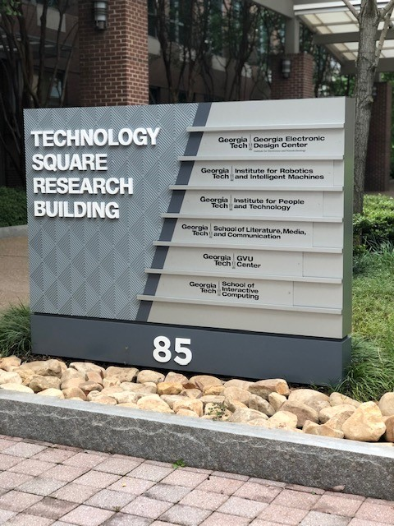

Table of Contents

- Purpose of TSRB
- Eligible Reservation Groups
- Meeting Rates and Fees
- Room Descriptions
- Site Visit
- Reservation Process
- Cancelation Process
- Setup/Breakdown Requirements and Responsibilities
- Signage
- Catering Policy
- Alcohol Policy
- Internet Connection
- Liability Insurance
- Event Logistics Committee and Off Campus Groups
- Possession and Use of Illegal Drugs
- Animal Policy
- Contact Information

Purpose of TSRB
TSRB supports the research and academic mission of the Georgia Institute of Technology. Therefore, organizing parties are prohibited from collecting any type of fees from attendees associated with meetings or events.

Eligible reservation groups
Members of the Georgia Tech community can log into GT Events with their Georgia Tech user ID and password to browse and reserve available TSRB spaces. Individuals who are not members of the Georgia Tech community cannot reserve space through GT Events but can obtain information on availability and fees by sending an email to TSRB staff.

Meeting rates and fees
The TSRB conference area is free if reserved by members of the Georgia Tech community for use during regular hours of operation: 8 a.m. to 5 p.m. Mon-Fri. After hours (including weekends) will incur a $300, 4-hour minimum fee for security/janitorial services plus $75 for each subsequent hour that follows. Invoices will be issued after the event has ended. Outstanding balances will prevent future reservations in the TSRB conference area until paid in full. Parking fees must be paid by the organizing party as TSRB will not validate parking. The Centergy Parking Deck, E82 is recommended for its proximity.

Room Descriptions
Room | Square Footage | Max.  Occupancy | Setup | INCLUDES
Auditorium  118 | 1875 | 93 | Permanent theatre seating | podium, built-in audiovisual, 2 projectors,  whiteboard, not equipped for virtual meetings
Banquet Hall  132 | 992 | 40 | Banquet style:  5 round tables  each w/ 8 chairs | podium, built-in audiovisual, projector
Banquet Hall  133 | 992 | 40 | Banquet style: 5 round tables  each w/ 8 chairs | podium, built-in audiovisual, projector
Banquet Hall  134 | 992 | 40 | Banquet style: 5 round tables  each w/ 8 chairs | podium, built-in audiovisual, projector
Breakout Room  130 | TBD | TBD | Conference/ Boardroom | TBD
Breakout Room  131 | TBD | TBD | Conference/ Boardroom | TBD
Pantry/Kitchen |  |  |  | sink, refrigerator, ice machine
Pre-Function Area | TBD | TBD | Dining | six sets of 4-person high top tables, four sets of  4-person dining tables

Site Visit
Site visits must be scheduled in advance by sending a request to TSRB staff.

Reservation Process
To make a reservation, a member of the Georgia Tech community is to submit a GT Event request. A confirmation number will generate once TSRB staff have approved the reservation. If the event is considered after-hours, an email request must also be sent to TSRB staff to secure the entire time slot as well as scheduling the mandatory security/janitorial services. Individuals who are not members of the Georgia Tech community cannot reserve space through GT Events but can obtain information on availability and fees by sending an email to TSRB staff.

Cancelation Process
To cancel, members of the Georgia Tech community may do so via GT Events unless the event is considered after hours. For an after-hours or institute guest event, a cancelation request including the confirmation notification must be emailed to TSRB staff no later than a week prior to the scheduled event. Cancelations made less than a week from the event will incur the 4-hour minimum charge for security/janitorial services if originally required.

Setup/Breakdown Requirements and responsibilities
- Equipment requests such as microphones, easels, external sidewalk sign, 6ft tables, additional trash receptacles, etc. must be requested with your reservation request or via email at least 5 business days prior to the event.
- The organizing party is responsible to seek audio visual services if needed. We strongly encourage AV system validation 30 minutes prior to your event. Please plan accordingly.
- The organizing party is responsible to designate an onsite coordinator who is present throughout the event.
- It is the responsibility of the onsite coordinator to arrange conference area setup as needed. TSRB staff can supervise if able but will not provide support to reconfigure rooms.
- Onsite coordinator may only utilize conference areas that were reserved ahead of time.
- The conference area is to be left in the same condition as it is found. For instance, tables and chairs are to be placed back into their original layout.
- Start and end times must include time for clean-up and removal of all food and beverages from meeting space.
- The conference area is inspected before and after all events daily. Excessive litter left behind and/or damage after the conference will encounter a cleanup or replacement fee which will be assessed at the discretion of TSRB staff. Charges may apply.
- TSRB is not responsible for damage to or loss of any merchandise or articles left in the conference area. Customer agrees to be responsible for any damages.

Signage
Please do not tape signs on walls or doors. Instead, please request one of the many a-frame easels that are onsite. If your group wishes to hang banners, please seek approval prior to the event. Additionally, TSRB Property Management requires utilization of our exterior sign (insert: 24” W x 36” H) should one be needed for directional purposes. The organizing party must produce their own insert.

Catering Policy
The TSRB conference area follows the Georgia Tech catering policy. It is the responsibility of the organizing party to secure approved catering for their event.

Alcohol Policy
An Alcohol Approval Form must be submitted for Georgia Tech events where alcoholic beverages will be served as prior approval is required. Please email the approved form to TSRB staff at least 7 business days before the event. For more information about alcohol requests, please send an email to alcohol-requests@gatech.edu.

Internet Connection
The Georgia Tech LAWN (Local Area Walkup & Wireless Network) is designed for students, faculty, staff, and institute guests who are mobile network users. GT LAWN provides access to the Internet from nearly every building on campus including offices, labs, classrooms, student residence halls, and outdoor spaces. Some campus locations like the library and many classrooms also provide wired (Ethernet) LAWN ports. There are three GT Wi-Fi services: eduroam, GTother, and GTvisitor. For additional Wi-Fi network access information, please visit this link.

Liability Insurance
Institute guests must have liability insurance to use the TSRB conference area. General Liability Insurance protects employees of the State, the Georgia Institute of Technology, and the University System of Georgia against personal liability for damages arising out of the performance of their job duties. For more information, please visit this link.

Event Logistics Committee and off campus groups
Event Logistics Committee: Student organization members, school and department administrators, and non-GT individuals may be required to meet with the Event Logistics Committee (ELC) depending on the size and scope of their event. Please send an email inquiry to events@spaceplan.gatech.edu for more information.

Possession and Use of Illegal Drugs
Georgia Tech does not permit or condone the illegal possession and/or use of controlled substances.

Animal Policy
As a rule, animals are not allowed within the TSRB conference area. However, we follow the guidelines laid out by the Americans With Disabilities Act of 1990 wherein service dogs are permitted.

Contact information
TSRB staff: events-tsrb@tsrb.gatech.edu or 404-385-4073
TSRB security: 404-872-7155
Audio visual services: avservices.oit.gatech.edu or 404-385-5555

